

**ATAR HUMAN BIOLOGY – UNIT 1**

**TASK 6 – MUSCULOSKELETAL SYSTEMS TEST**

**NAME: _________________________________ WEIGHTING: 4 %**

**DUE DATE: _________________________________ MARK: ______ / = _____ %**

Important Information for Students

1. There are THREE sections in this test - Multiple Choice, Short Answer and Extended Answer.
2. This is a closed-book assessment (no notes are allowed)
3. The time allowed to complete the test is 55 minutes.
4. Write your answers to the Multiple Choice section on the **separate** answer sheet provided.
5. Write your answers to the Short Answer section in space provided.
6. Write your answers to the Extended Answer section in space provided.

|  |  |  |
| --- | --- | --- |
| Sections | **Marks Allocation** | **Your Total** |
| **A - Multiple Choice** | 10 |  |
| **B - Short Answer** | 18 |  |
| **C - Extended Answer** | 6 |  |
| **TOTAL** | 34 |  |

**Multi Choice Section (10 questions – 10 Marks)**

**1.** A vertical jump mainly involves muscles located in:

1. the front of the thigh and the back of the calf.
2. the front of the thigh and the front of the calf.
3. the back of the thigh and the front of the calf.
4. the back of the thigh and the back of the calf.

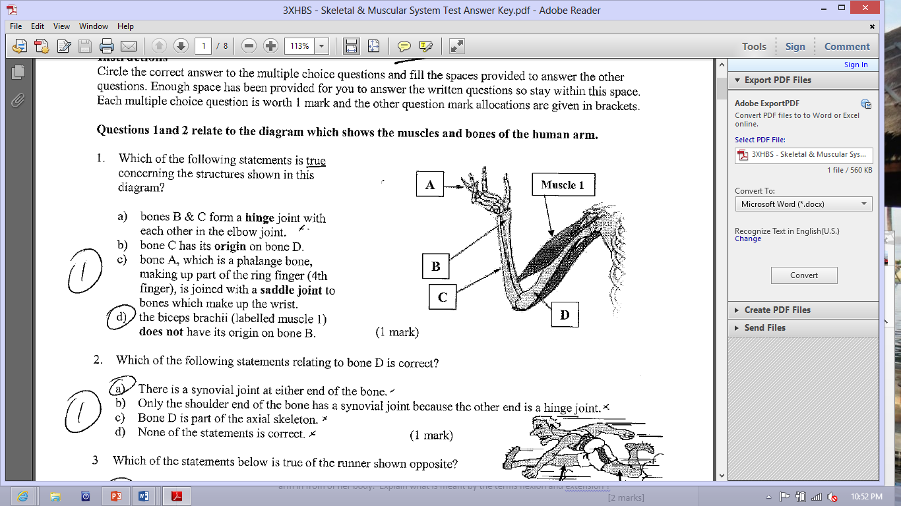**2.** Which of the following statement is true concerning the structures shown in this diagram ?

1. Bones B & C form a hinge joint with each other in the elbow joint
2. Bone C has its origin on bone D
3. Bone A, which is a phalange bone, making up part of the ring finger) is joined with a saddle joint to bones which make up the wrist
4. The biceps (labelled muscle 1) does not have its origin on bone B

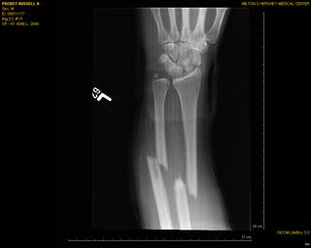

3. The X-ray photo shows an injured arm. Which of the following statements is correct? The diagram shows:

1. Bones of a person suffering from osteoarthritis
2. A badly sprained wrist with several of the bones being displaced due to trauma
3. Damage to the radius and ulna bones of the forearm

d. The effect of an over-extension of muscles in the forearm causing ultra-rotation of the radius resulting in significant dislocation of the bones.

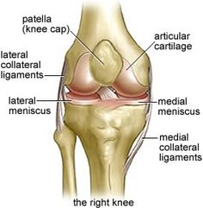4. A common sports injury suffered by sportsmen is the rupturing of the cruciate ligament in a knee joint. In the diagram, the posterior cruciate ligament (PCL) has been torn and the knee will need to be reconstructed. In this diagram, several structures have been labelled A, B, C and D. Which of the following statements is correct?

C

A

B

1. Structure A between C and D is a bursa
2. Structure C is cartilage

D

1. Structure C is a ligament as it holds B and D together
2. B and D from a pivot joint

5. A bursa is:

a. part of a bone

b. a sac of fluid often found between tendons and bone

c. part of the pelvis

d. connective tissue found in muscles.

6. The range of movement permitted at a pivot joint includes:

a. rotation.

b. flexion and extension.

c. abduction and adduction.

d. circumduction.

7. The attachment of a muscle at its moveable end is the :

a. flexor.

b. insertion.

c. tone

d. origin.

8. The bones in a joint are attached together by:

a. tendons.

b. ligaments.

c. synovial fluid.

d. articular cartilage.

9. Which of the following is not an example of a synovial joint?

a. The knee.

b. The cranium.

c. The thumb and palm.

d. The elbow.

10. Which of the following bones is not part of the appendicular skeleton?

a. The ribs.

b. The humorous.

c. The tibia.

d. The pelvis.

End of Multi-choice.

**Short Answer Section (4 questions – 18 marks)**

[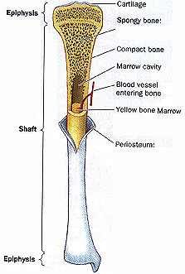](http://www.physioweb.org/skeletal/bone_tissue.html)

11.

1. Describe two major differences between the spongy bone and the compact bone. *(2 marks)*

______________________________________________

______________________________________________

______________________________________________

______________________________________________

1. Explain why the epiphyses of the long bones are composed of spongy bone while the diaphysis is composed of compact bone. *(2 marks)*

______________________________________________________________________________

______________________________________________________________________________

______________________________________________________________________________

_____________________________________________________________________________

12. Vertebrae are joined by cartilaginous joints.

1. Name the type of cartilage that joins vertebrae to each other. *(1 mark)*

________________________________________________

1. Describe how the structure of cartilage referred to in part (i) suits its function. *(2 marks)*

___________________________________________________________________________

___________________________________________________________________________

___________________________________________________________________________

13.  Part (a) of the question refers to the diagram below.

1. The diagram represents the sliding filament model of muscle contraction. A sarcomere in a skeletal muscle is shown in the relaxed position.
2. Identify the proteins labeled as A and B in the diagram.  *(2 marks)*

A _____________________________

B _____________________________

1. In the box below, accurately draw the same sarcomere as it would appear when the muscle is contracted. *(2 marks)*
2. Explain what will have to happen for the sarcomere to return back to normal. *(2 marks)*

________________________________________________________________________________________________________________________________________________

(b) Name the three types of muscle that can be found in the body. *(1 mark)*

_________________________________________________________________________________________________________________________________________________________________________________________________________________________________

14. The Australian gymnast fell off the horizontal bars during the World Cup meeting last month and broke the epiphysis of her femur, causing damage to the bone and cartilage in that joint. She was hoping to compete in Rio but that would depend on the healing processes occurring in the joint.

Discuss the differences in the healing processes of the cartilage and the bone. *(4 marks)*

____________________________________________________________________________________________________________________________________________________________________________________________________________________________________________________________________________________________________________________________________________________________________________________________________________________________________________________________________________________________________________________________________________________________________________________________________________________________________________________________________________________________________________________________________________________________________________________________________________________________________________________________________________________________________________________________________________________________________________________________________________

[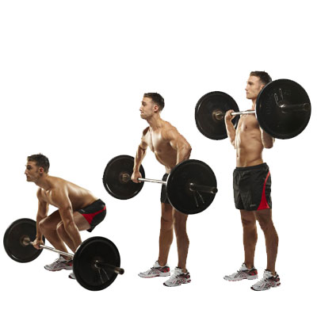](http://www.google.com.au/url?sa=i&rct=j&q=&esrc=s&frm=1&source=images&cd=&cad=rja&uact=8&ved=0ahUKEwiRmNmhvq7NAhXBkpQKHdMlB1EQjRwIBw&url=http://www.top.me/fitness/take-your-fitness-to-the-next-level-with-complex-training-1100.html&bvm=bv.124817099,d.dGo&psig=AFQjCNHMV2agSm44aHcdA0Z3ZtpZXuj0jA&ust=1466233100823096)**Long Answer Section (one question - 6 marks)**

The “clean and jerk” is an Olympic sport for the powerful. The use of the legs and arms are shown in the diagram opposite.

Using the diagram to help you, discuss how the major muscles, bones and joints in the leg move to achieve the movement shown in the diagram. Include all names and the actions performed. *(6 marks)*

_______________________________________________________________________________________________________________________________________________________________________________________________________________________________________________________________________________________________________________________________________________________________________________________________________________________________________________________________________________________________________________________________________________________________________________________________________________________________________________________________________________________________________________________________________________________________________________________________________________________________________________________________________________________________________________________________________________________________________________________________________________________________________________________________________________________________________________________________________________________________________________________________________________________________________________________________________________________________________________________________________________________________________________________________________________________________________________________________________________________________________________________________________________________________________________________________________________________________________________________________________________________________________________________________________________________________________________________________________________________________________________________________________________________________________________________________________________________________________________________________________________________________________________________________________________________________________________________________________________________________________________________________________________________________________________________________